**Agricultural Related Query Clarifier System**

VIJAI KUMAR S GUIDED BY:

MCA(R) Dr.D.NARASHIMAN

2020178060

**Problem Statement**

To provide solution for agriculture related queries

**Need for new system**

* Traditionally Field officers visit the farmlands and provide training, advice, and support to the farmers
* Many of the rural villages misses this facility
* Wastage of time and money spent on obtaining information or contacting officials
* Nowadays many young generation people are come forward in Agricultural field
* By this they are struggled to clarify their any basic doubts about farming. Lots of people are calling Kissan Call Centre (Owned by Government) to clarify their basic doubts

**Architecture Diagram:**

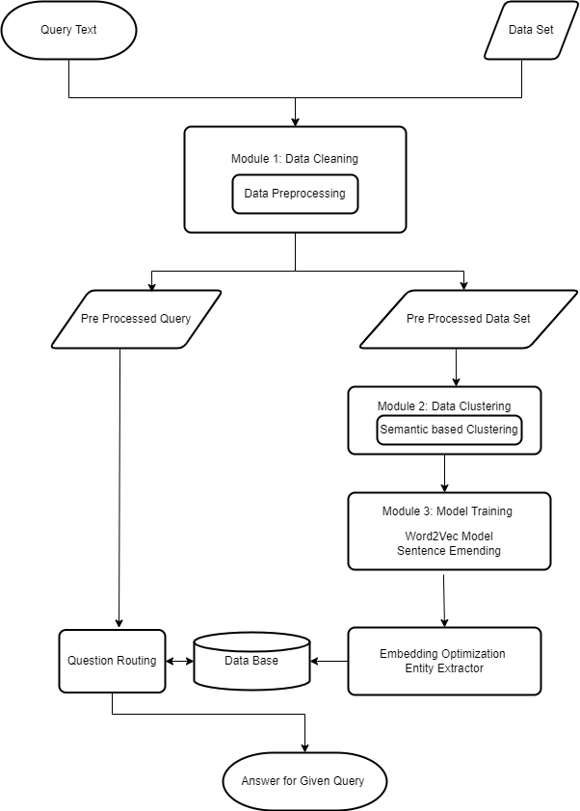

**Details of Data Set:**

|  |  |
| --- | --- |
| Size | 300 MB |
| No of Records | 20 lakh |
| Source | Kissan Call Center(Government Owned) |

**Features in Dataset:**

1) **Season**: This feature contains different season about the query asked, ex: Rabi, Jayad, and Kharif.

|  |  |
| --- | --- |
| Rabi | March to June |
| Kharif | Juneto September |
| Jayad | October to March |

2) **Sector**: KCC classify the query based on sectors like Agriculture, Horticulture, Fisheries, and Animal Husbandry.

3) **Crop:**This field gives use the information about for which crop respective has been asked for example Apple, Banana, Rice, Wheat, Garlic, Cucumber, etc.

4) **Query Type**:Disease, Feed preparation, Training, poultry, Verities, Water management, Agricultural Mechanization, etc.

5) **Query Text**:Contains the Query statement asked by the farmer, this query has been entered by DEO from government.

6) **KCC Answer**: Contains Solution or suggestions for the Respective Query asked by farmer.

7) **State and District name**:Contains particular query asked from which State and District. This feature helps more to organize our dataset.

8) **Created on:**Contains Data and time of the particular query is asked.

**Sample Data:**



**Module Wise Details**

1) **Data Cleaning**:

Data Flow Diagram:

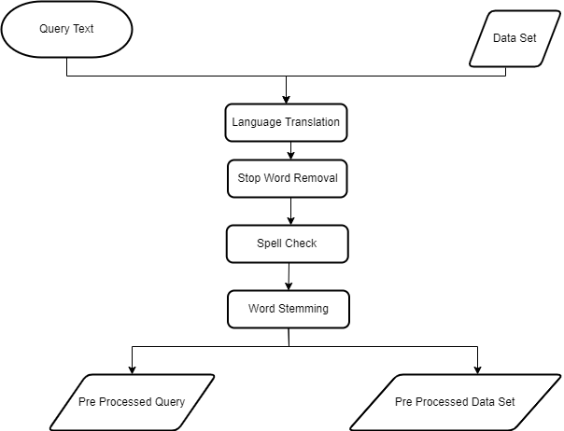

**Sample Input**:

{"Season":"RABI","Sector":"AGRICULTURE","Category":"Others","Crop":"Others","QueryType":"Government Schemes","QueryText":"FARMER ASKED ABOUT PM KISAN?","KccAns":"पीएमकिसानसाठीतुमच्याजवळीलतहसीलऑफिसलाजाऊनभेटद्यावीधन्यवाद","StateName":"GOA","DistrictName":"GOA SOUTH","BlockName":"SANGUEM","CreatedOn":"2022-04-01T10:47:15.43"}

**Sample Output**:

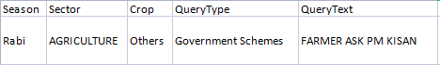



2) **Text Clustering:**

Data Flow Diagram:

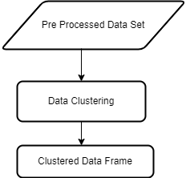

Clustred data frame contains Query, Query Type, State and District Name, Time of Query, List of Answer for the query.

Algorithm:

total_dictionary = {}  
with open('/content/drive/MyDrive/project/Data Set/Final_merged1.csv') as fin:

    reader = csv.DictReader(fin)

    for row in reader:

      values = [row['QueryType'], row['StateName'],row['DistrictName'],row['CreatedOn'],row['Answer']]  
      query = row['Query']

      query = (" ".join(query.split()))

        # branches[row['River Name']].append(branch)

      total_dictionary.setdefault(query, [])

      total_dictionary[query].append(values)  
with open('/content/drive/MyDrive/project/Data Set/Final_merged2.csv') as fin:

    reader = csv.DictReader(fin)

    for row in reader:

      values = [row['QueryType'], row['StateName'],row['DistrictName'],row['CreatedOn'],row['Answer']]  
      query = row['Query']

      query = (" ".join(query.split()))

        # branches[row['River Name']].append(branch)

      total_dictionary.setdefault(query, [])

      total_dictionary[query].append(values)  
with open('/content/drive/MyDrive/project/Data Set/Final_merged3.csv') as fin:

    reader = csv.DictReader(fin)

    for row in reader:

      values = [row['QueryType'], row['StateName'],row['DistrictName'],row['CreatedOn'],row['Answer']]  
      query = row['Query']

      query = (" ".join(query.split()))

        # branches[row['River Name']].append(branch)

      total_dictionary.setdefault(query, [])

      total_dictionary[query].append(values)

3) **Training Model:**

Data Flow Diagram:

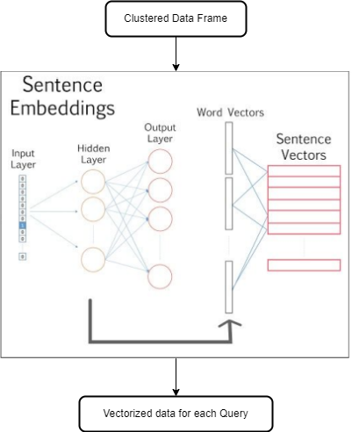

**Details of User Interface:**

* **Login Page**

User has to provide necessary details to login like Name, Gmail ID.

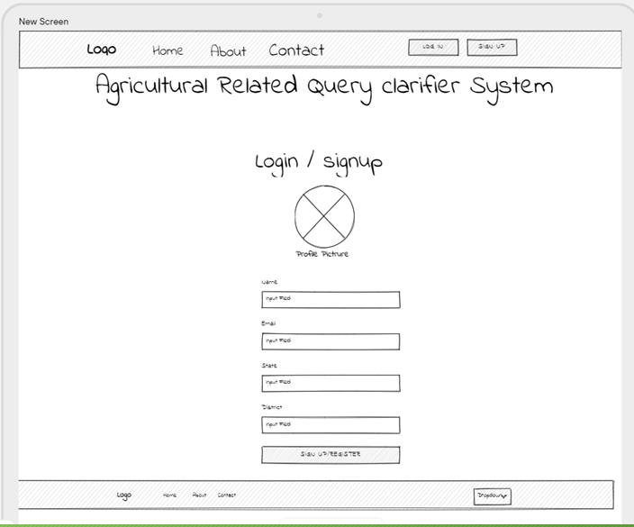

* **Query Clarifying page**

This page contains feature where user can enter their agricultural related query and will get response for the same.

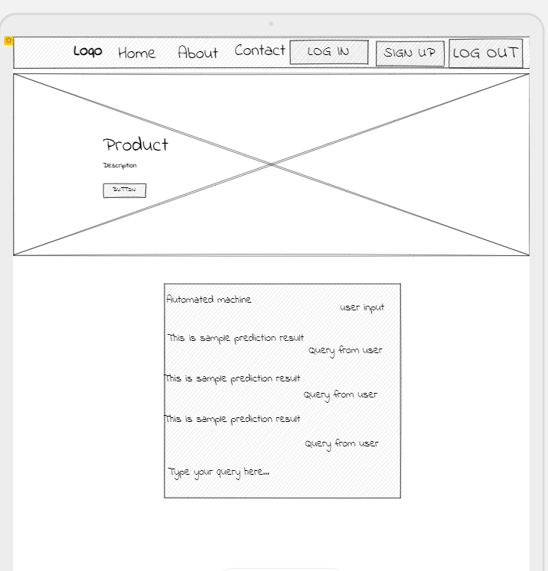

**Evaluation Metrics**

In order to evaluate our metric for the prediction of the test data questions. Using these predictions and the ground truth we can define a threshold for both scores. The threshold tells the model which predictions are to be considered as good results. By using the metrics for ranking our answers, where the final predicted answer is given by

Output answer = argmax [score (question, answeri)]

**Reference:**

1. Bikel, Daniel M, Richard Schwartz and Ralph M. Weischedel, “ An algorithm that learns what’s in a name”. Machine Learning 1999 Issue No.34 pp. 211–2, 1999.
2. Sanjeev Arora, Yingyu Liang, Tengyu Ma, “A simple but tough-to-beat baseline for sentence embedding's”, in the proceeding of International Conference on Learning Representations, 2017
3. Xiaoxue Shen , Adele Lu Jia, Siqi Shen and Yong Dou, “Helping the Ineloquent Farmers: Finding Experts for Questions with Limited Text” ---------- 2020.
4. Rong and Xin, “Word2vec Parameter Learning Explained” , Coronell University , 2016.
5. SerhadSarica ,JianxiLuo “Stopwords in technical language processing”. Journal PLOS ONE August 2021
6. Banerjee, S., Pedersen, T., An adapted Lesk algorithm for word sense disambiguation using WordNet (2002)
7. Ming Che Lee,1 Jia Wei Chang,2 and Tung Cheng Hsieh3A “Grammar-Based Semantic Similarity Algorithm for Natural Language Sentences” Hindawi Publishing Corporation, The Scientific World Journal Volume 2014, Article ID 437162,17 pages.